AIIA, SYDNEY, Tue 15 April 2014

Jusuf Wanandi, 1982:

Future Australia-Indonesia relations

Relations between Indonesia-Australia are in general not very friendly, and have been disturbed by the East Timor issue, due to misunderstanding and misperceptions that have developed between the two nations which are so different in many respects.

The increase in the number of Australian tourists coming to Indonesia has hardly improved the understanding between the two nations. Economic relations are relatively minimal. Government-to-government relations are quite good, although some elements in the Australian government remain suspicious of Indonesia and some elements in the Indonesian government do not see Australia’s importance whatsoever as a close neighbour. Relations among politicians are equally minimal. What seems to be annoying is the fact that issues on Indonesia and relations between Indonesia and Australia oftentimes have been used by Australian politicians for their domestic consumption.

Among academics of both sides there still exist prejudices, such as on Australia’s white-policy of the past or on the romantics of the old-order in Indonesia. Prejudices on the part of the mass media are most damaging. It is often felt that the ‘self-righteousness’ attitude of the Australian press in analysing Indonesian affairs and the ignorance of the Indonesia press on Australian affairs have made it all the more difficult to gradually eliminate those mutual prejudices.

Things to do to ‘alleviate the misunderstandings on both sides’

‘… something needs to be done to alleviate the misunderstandings on both side.
- There must, first of all, be recognition and appreciate of the differences in societal values and customs, political systems as well as economic development. Moralistic attitudes on the part of Australians … would not serve to nurturing greater understanding and cooperation. Perceptions of an expansionist Indonesia, which are still widespread in Australia, are not equally helpful.
- Similarly, on the part of Indonesians, especially the leaders, there is a need to gradually overcome the misfeelings towards Australia …
- … steps must be taken to increase relations in the economic field and trade relations, including in natural resources such as iron ore and coal, as well as cooperation in industries and advanced technologies, including in defence. Cooperation in the field of education and science … should be further encouraged.
- More extensive relations among mass media people are most important … One should admit that the Australian press is largely responsive for the deterioration in bilateral relations. Overreactions on the part of Indonesia towards criticism aired by the Australian mass media have cause further deterioration in our relations … the Australian press could be more sensitive to and learn to appreciate the role of the mass media in a developing Indonesian society. The Indonesian mass media has been quite ignorant of Australian affairs, and should start to consider to open up offices in Australia …

Jusuf Wanandi, ‘Australia-Indonesia relations in the context of developments in the Asia-Pacific’, in Regional dimensions of Indonesia-Australia relations, Yayasan Proklomasi, CSIS, Jakarta, 1984.

INDONESIAN POLITICAL MAP –2014
(Adapted from Feith and Castles)

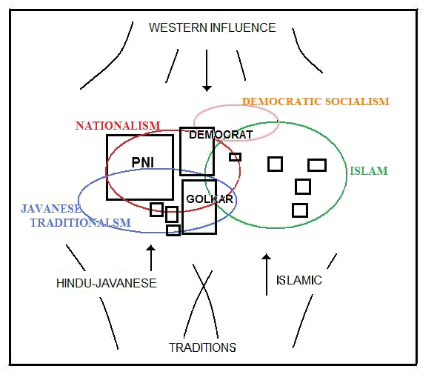

Table: ASEAN Key Statistics, 2012
 | Mid-yr |  |  | GDP |  |  | GDP PPP
 | pop |  |  | (PPP) |  |  | per capita
 | 2012 | % |  | 2012 | % |  | $ | Index
 | (mill) |  |  | (US$ bill)
Indonesia | 247 | 40 |  | 1,223 | 33 |  | 4,947 | 82
Philippines | 96 | 16 |  | 427 | 11 |  | 4,457 | 74
Vietnam | 89 | 14 |  | 355 | 10 |  | 3,998 | 66
Thailand | 64 | 10 |  | 692 | 19 |  | 10,745 | 177
Myanmar | 61 | 10 |  | 110 | 3 |  | 1,803 | 30
Malaysia | 29 | 5 |  | 501 | 13 |  | 17,099 | 282
Cambodia | 15 | 2 |  | 37 | 1 |  | 2,500 | 41
Laos | 7 | 1 |  | 19 | 1 |  | 2,923 | 48
Singapore | 5 | 1 |  | 328 | 9 |  | 61,887 | 1,022
Brunei | 0 | 0 |  | 22 | 1 |  | 55,000 | 909
TOTAL | 614 | 100 |  | 3,714 | 100 |  | 6,054 | 100
China | 1354 |  |  | 12,471 |  |  | 9,210
India | 1213 |  |  | 4,793 |  |  | 3,950
Japan | 128 |  |  | 4,491 |  |  | 35,196
Australia | 23 |  |  | 1,008 |  |  | 44,405

 |  |  | April 2014
MAIN ECONOMIC INDICATORS, INDONESIA AND AUSTRALIA, 2012
Indicators | Units | INDONESIA | AUSTRALIA
Key indicators
GDP total | $US Bn | 850 | 1,530
GDP growth rate | % pa | 6 | 3
Inflation | % annual | 5 | 2
Population | Million | 247 | 23
GDP, per capita | $US | 3,600 | 67,400
Gross capital formation, total
Share of GDP | % of GDP | 36 | 28
Total | $US Bn | 316 | 428
Per capita | $US | 1,280 | 18,850
Value added (structure of the economy)
Agriculture | % of GDP | 14 | 2
Industry | % of GDP | 47 | 28
Services | % of GDP | 39 | 70
Total | % of GDP | 100 | 100
Trade and investment indicators
Exports | % of GDP | 24 | 21
Imports | % of GDP | 26 | 21
Balance of trade | % of GDP | -2 | 0
Current account balance | % of GDP | -3 | -4
Trade as a share of GDP | % of GDP | 50 | 42
Foreign Direct Investment, net inflows
Total | $US Bn | 20 | 57
Per capita | $US | 80 | 2,510
As share of GDP | % of GDP | 2 | 4
Government indicators
Expenditure
Total | $US Bn | 149 | 400
Share of GDP | % of GDP | 18 | 26
Per capita | $US | 600 | 17,605
Revenue
Total | $US Bn | 133 | 350
Share of GDP | % of GDP | 16 | 23
Per capita | $US | 540 | 15,600
Infrastructure indicators
Electric power consumption | kWh per cap | 700 | 10,700
Improved sanitation (population with access) | % | 59 | 100
Improved water source (population with access) | % | 85 | 100
Internet users | per 100 pop | 15 | 85
Mobile phones | per 100 pop | 114 | 106
Passenger cars | per 1,000 pop | 39 | 560
Source: World Bank Quick Query Database.

