Please complete the attached form and post, fax, or email to AIIA at the address above. If you have your credit card number at hand, you can also lodge your order by calling AIIA at the phone number above.

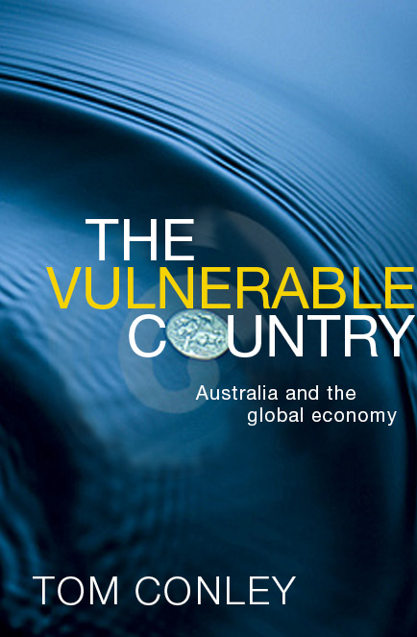

The Vulnerable Country
Australia and the global economy
Author: Tom Conley
UNSW Press, August 2009. Paperback, 304pp

Australia was born vulnerable. From its beginnings as a precarious convict settlement on the 'other side of the world', through the development of self-governing colonies, to Federation and beyond, recognising and dealing with vulnerability led Australians to embrace an insular attitude to the outside world, which in turn translated into state control over the economy and highly protectionist policies. So how did Australia transform from a protected, insular country to an outwardly focused, globalised one? And why, in the current economic climate, should Australia resist a return to its protectionist past? The Vulnerable Country begins with historical analysis of the interaction between politics and economics, covers the credit crunch of 2007 and culminates with the current global financial crisis. Tom Conley argues that now, more than ever, the state has a responsibility to promote diversification of trade while regulating economic activity and ensuring that the benefits of growth are spread as widely as possible.

Dr. Tom Conley is program director of the Masters of Asian Studies and International Relations in the Griffith Business School at Griffith University. He has published widely and is a frequent commentator on economic matters

ISBN | 9781742230122
Recommended retail price |  | A$39.95
AIIA member price |  | A$29.95
Non-members |  | A$36.00

Postage & packing
For orders within Australia, please add $AU 8.00 per book. Minimum charge $AU 4.00

For bulk or international orders, postage will be charged at cost.
Qty | Product or Title | Total Price $A
Subtotal
Postage & packing
Total

ADDRESS

 | Billing address (address to which your credit card bill or tax invoice is sent) | Delivery address (if different from billing address)
First name
Family name
Department/Faculty
University/Company
Street/PO Box
City/Town/Suburb
State
Postcode/Zip
Country
Email
Telephone

Want to become a MEMBER?

Enjoy all the advantages of an AIIA membership:

▪ free entry to speakers’ meetings
▪ updates and newsletters
▪ subscription to the Australian
Journal of International Affairs
▪ special offers and other member
benefits

Go to www.aiia.asn.au
to join your local branch
PAYMENT

□ Please send me a tax invoice OR Please charge the total above to my
□ MasterCard □ BankCard □ Visa

Card number
Expiry date (MM/YY) | /

(Signature) (Date)

